Curso AceleraDev Codenation

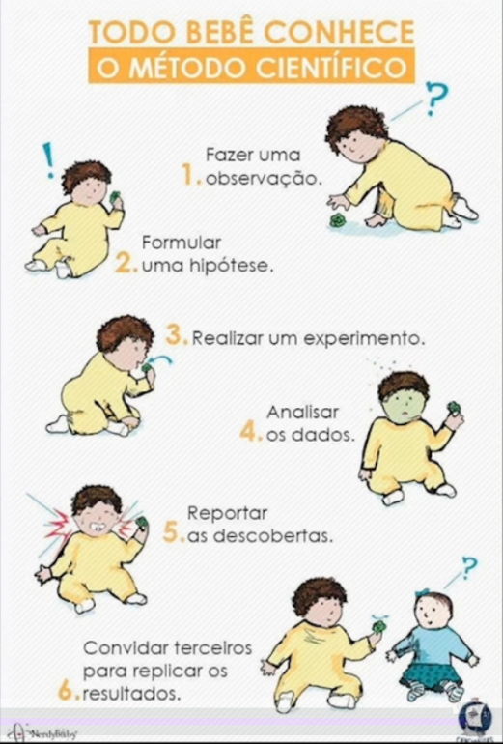

**Papéis em projetos de dados**

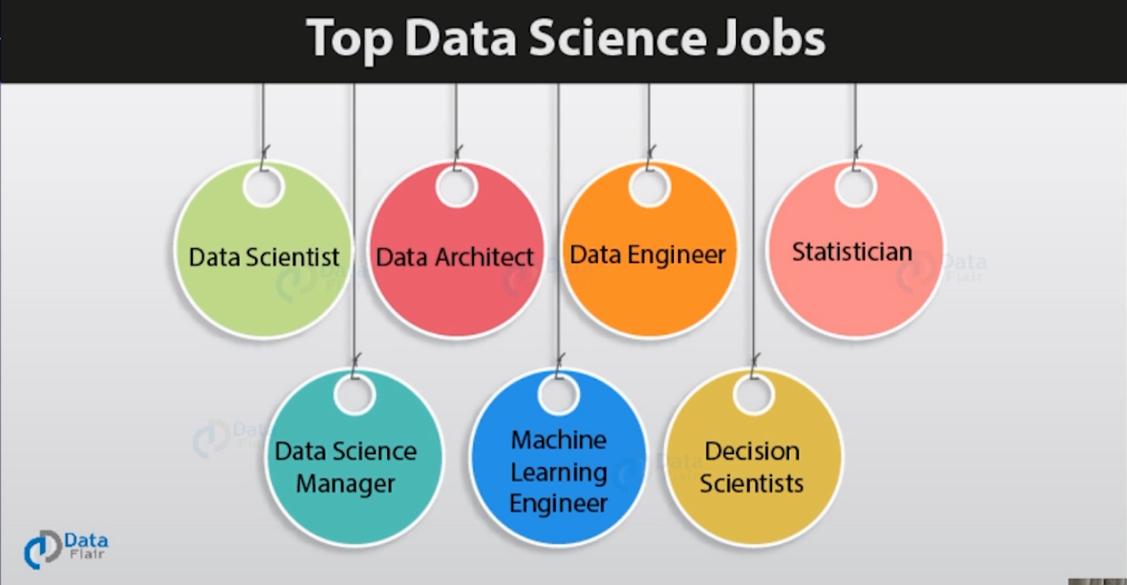

<https://data-flair.training/blogs/top-data-science-jobs/>

### 1. Data Scientist

Data Scientists are analytical experts who are responsible for **finding insights and patterns in the data**. A Data Scientist is responsible for handling raw data, analyzing the data, implementing various statistical procedures, visualizing the data and generating insights from it. He/she churns raw data and transforms it into meaningful products. A Data Scientist is also responsible for handling both structured and unstructured information.

A Data Scientist must have knowledge of various tools like Hadoop, R, Python, SAS, etc. Knowledge of data preprocessing, visualization and prediction are some of the important requirements of a Data Scientist.

### 4. Data Science Manager

A Data Science Manager is responsible for **handling and managing data science projects**. A Data Science manager handles the team and manages the performance to meet project deadlines. Usually, data science managers have an average of five-year experience in any of the data science domain like date engineering, data science or analysis.

Data Science managers are responsible for planning and curating a roadmap for the data science team to follow. Furthermore, they are responsible for executing the plan of action and delivering the results before the deadline. He/She should also have strong communication and leadership skills in order to guide the team efficiently. The average salary for a data science manager is – **$69,059/yr**.

### 7. Decision Scientists

The field of decision science is a relatively new field. Decision Scientists help the company to **make business decisions** with the help of tools like [Artificial Intelligence](https://data-flair.training/blogs/artificial-intelligence-tutorial/) and Machine Learning. It is a part of data science that extends to design thinking and behavioral sciences to better understand the clients. The average salary of a decision scientist is **$69,192/yr**.

**Tipos de soluções analíticas**

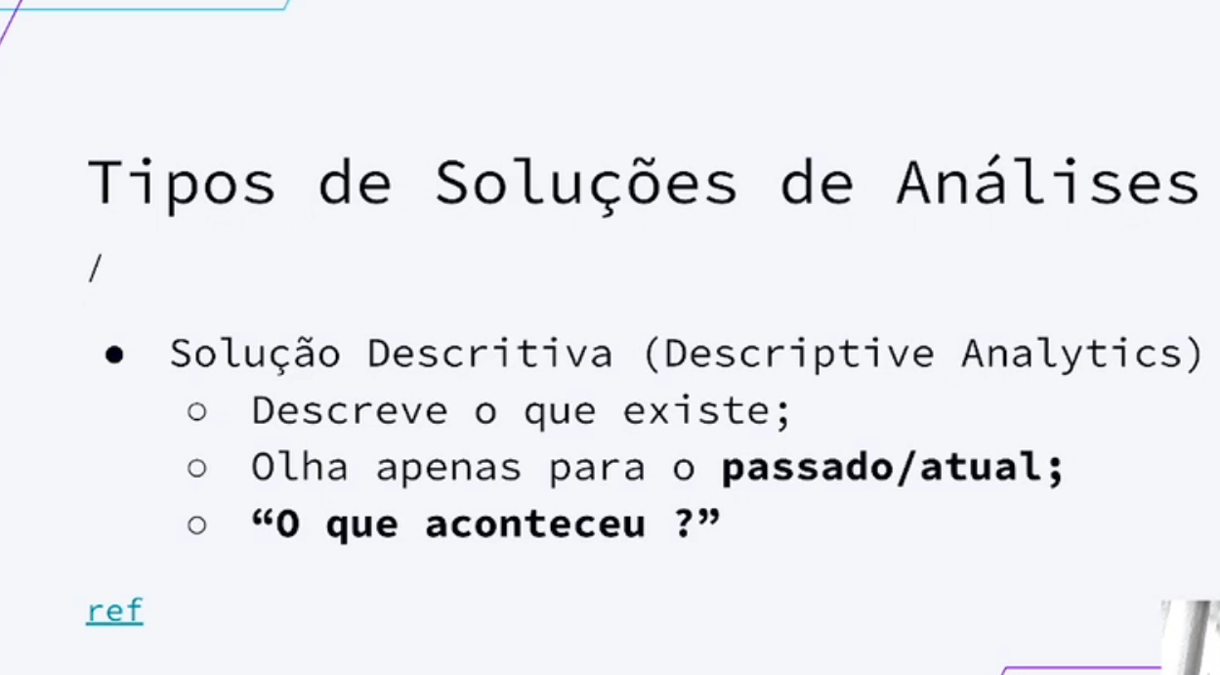

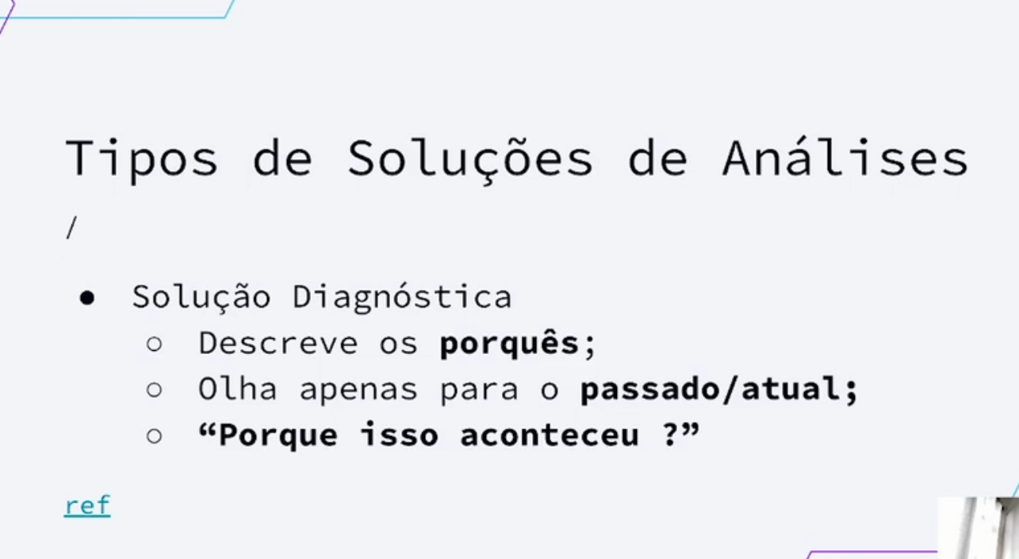

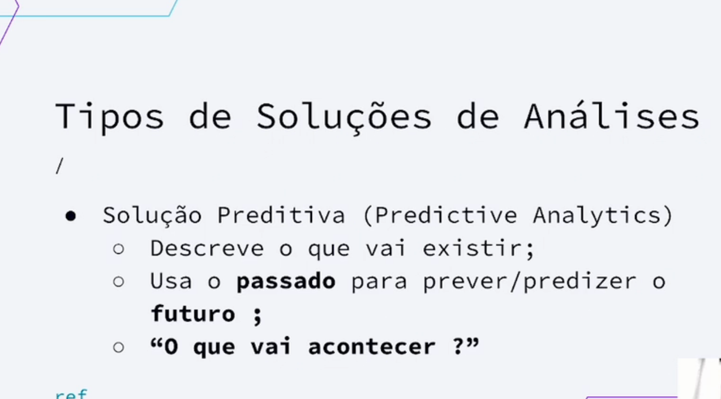

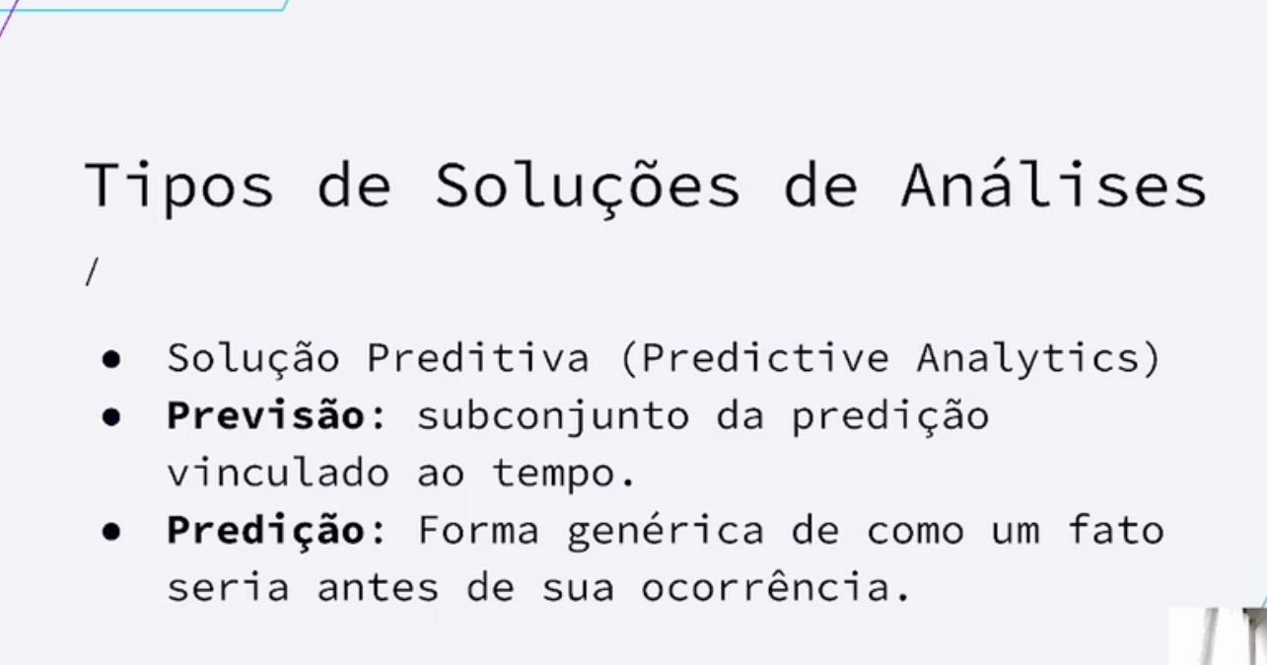

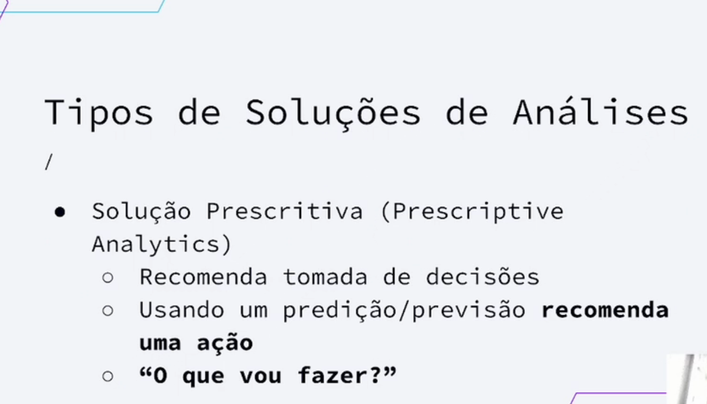

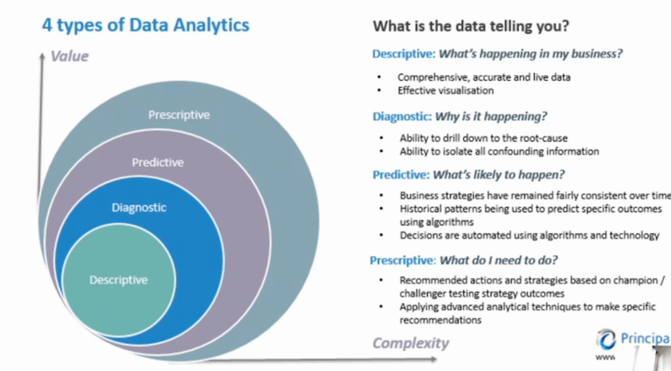

**7 tipos de problemas resolvidos por DS**

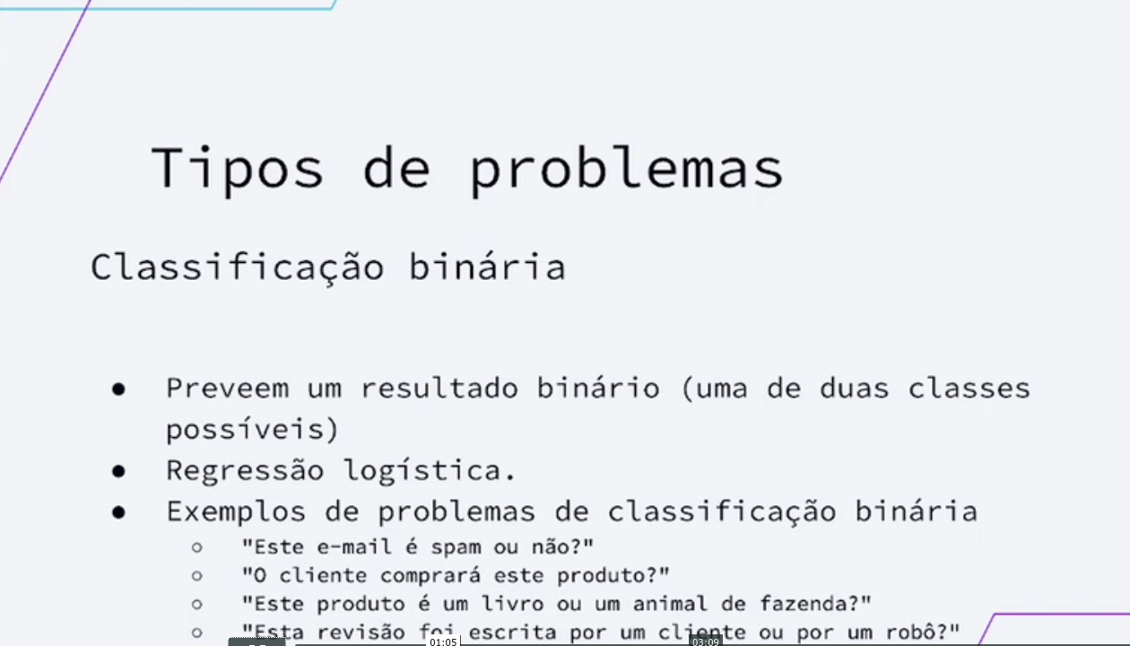

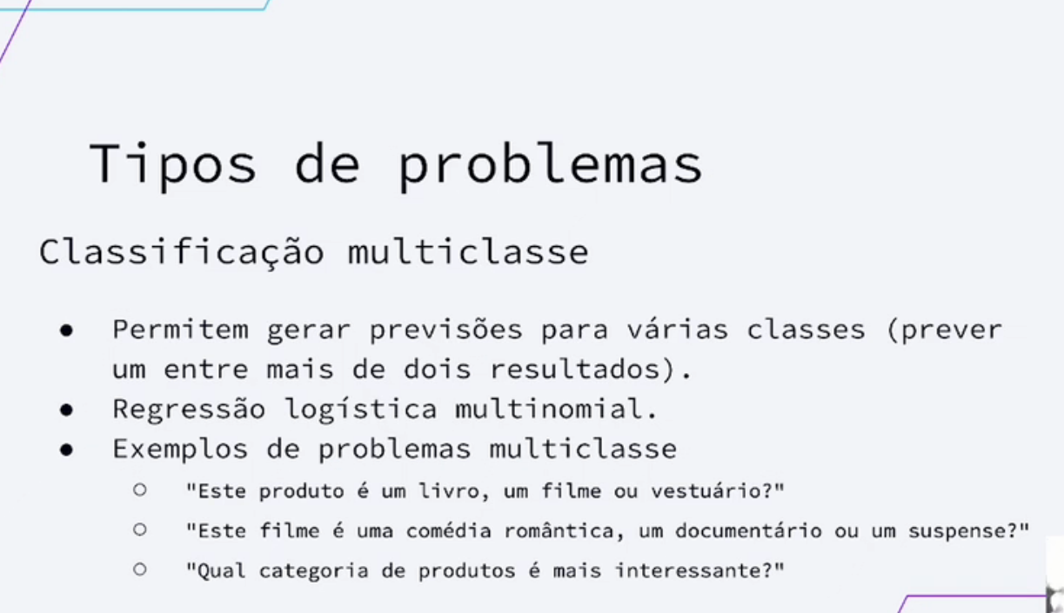

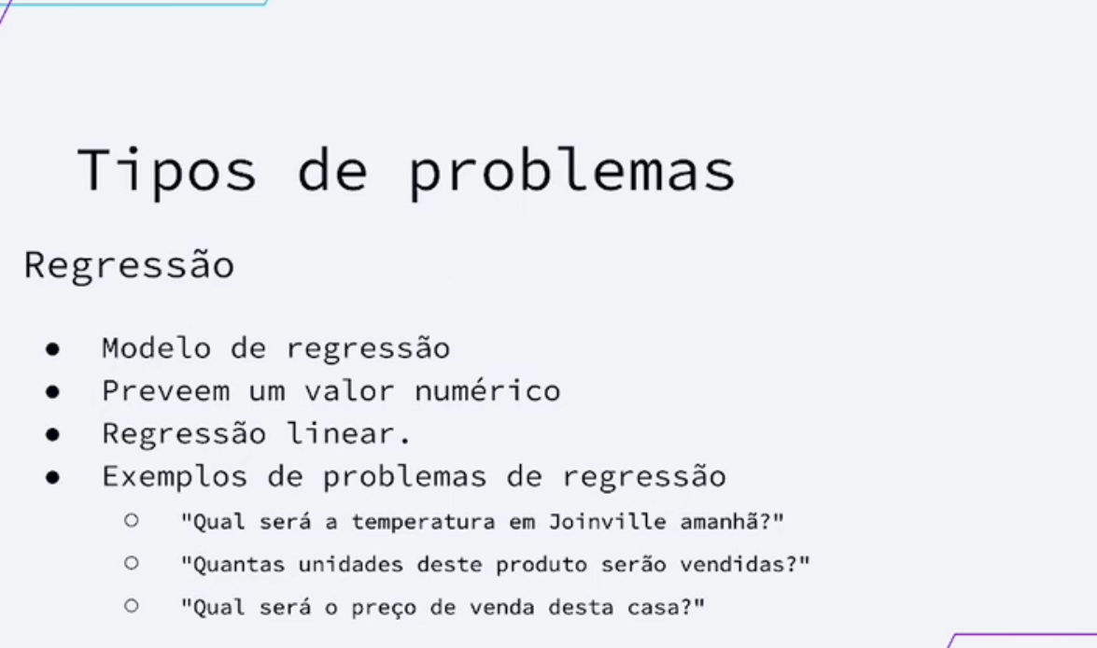

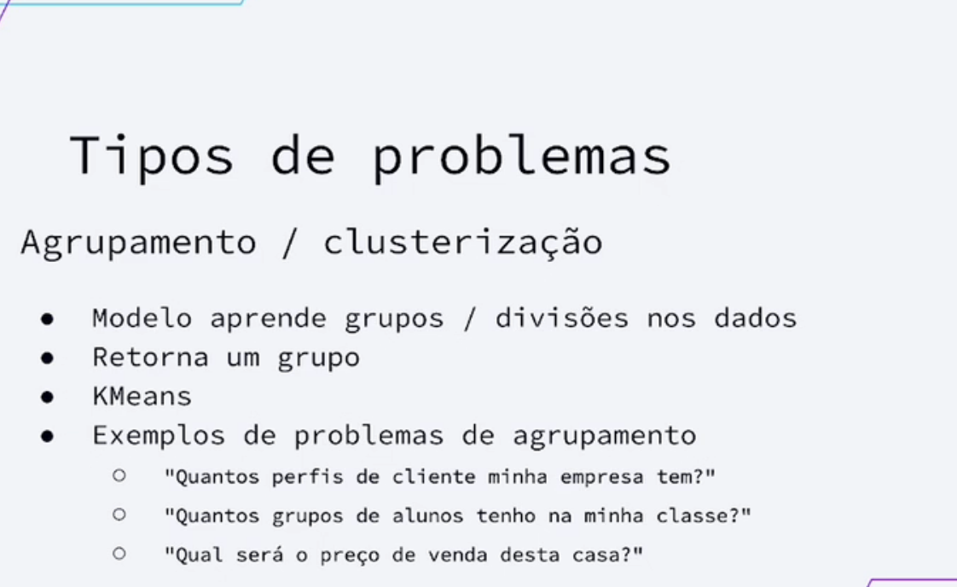

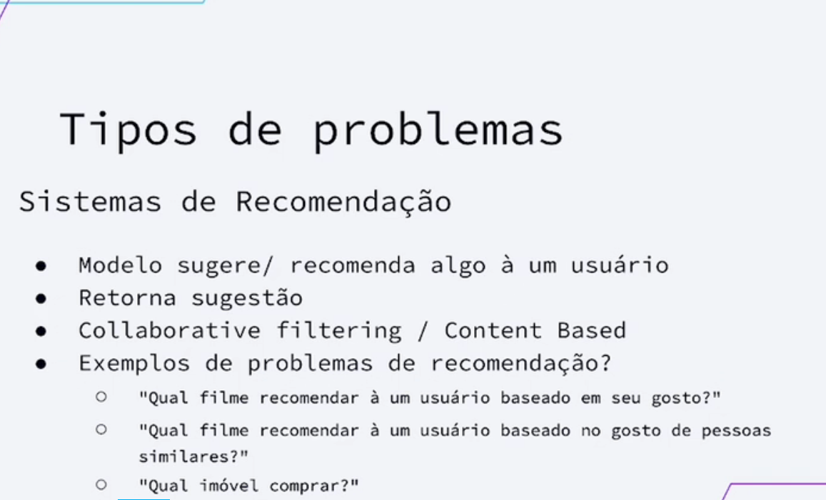

Tipos de Aprendizados

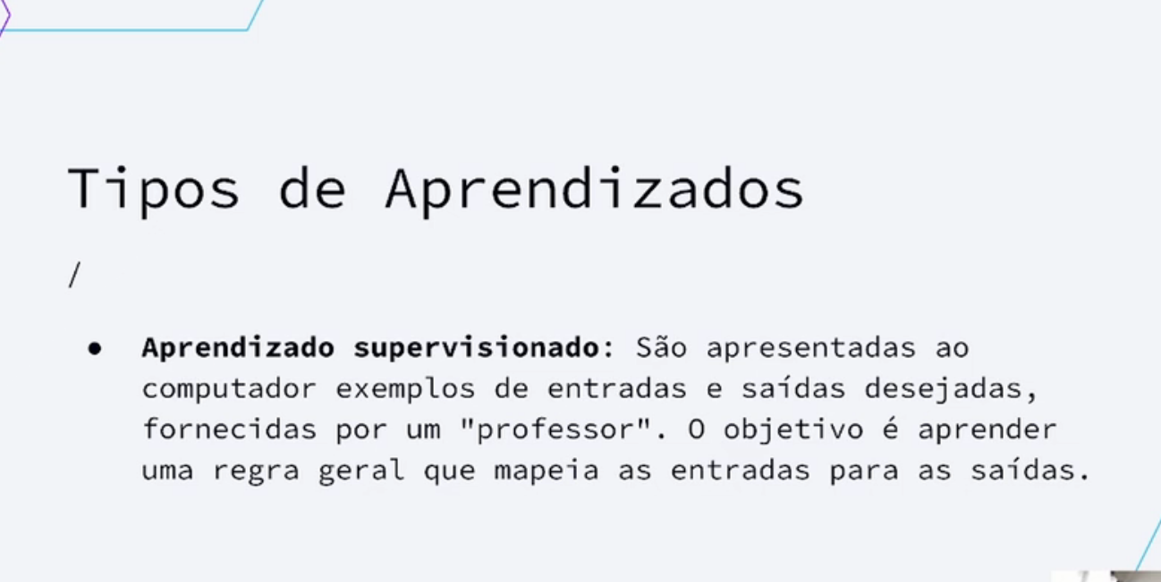

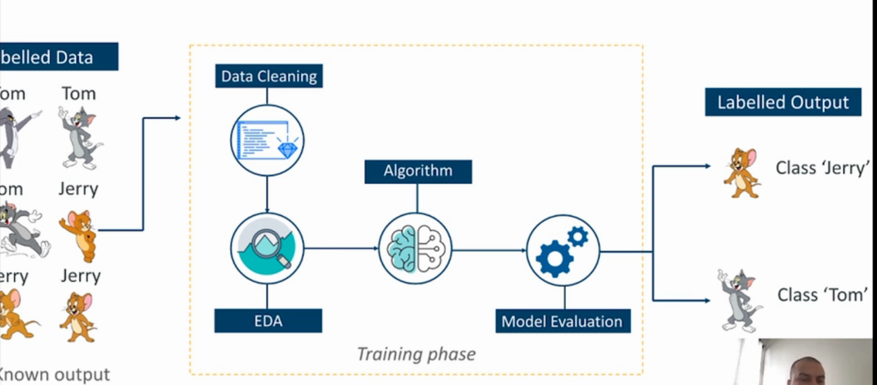

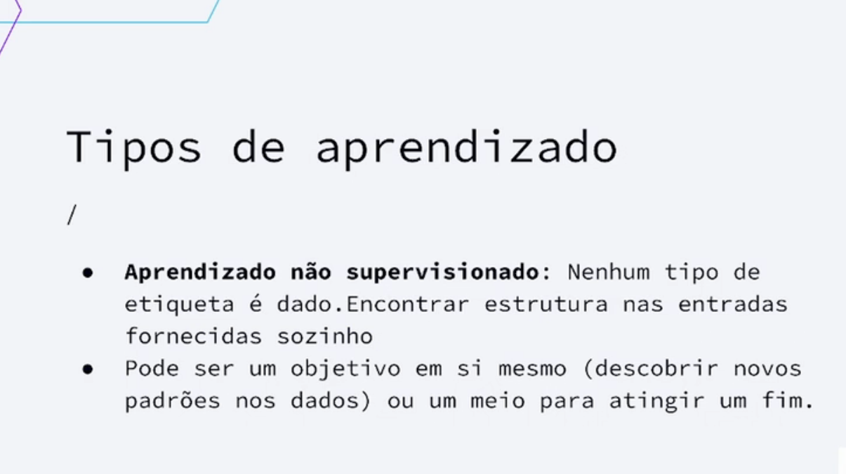

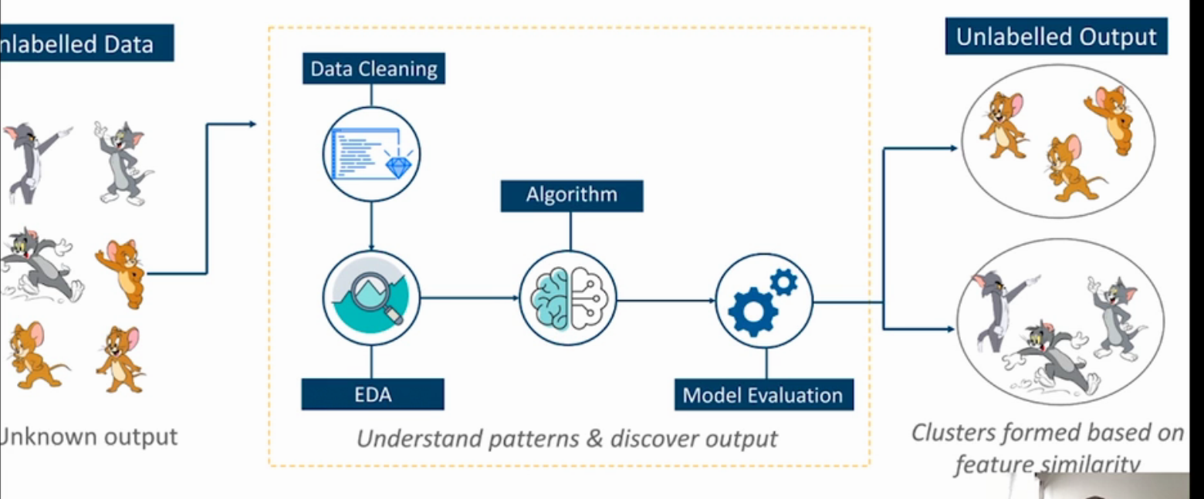

Maturidade com Analytics

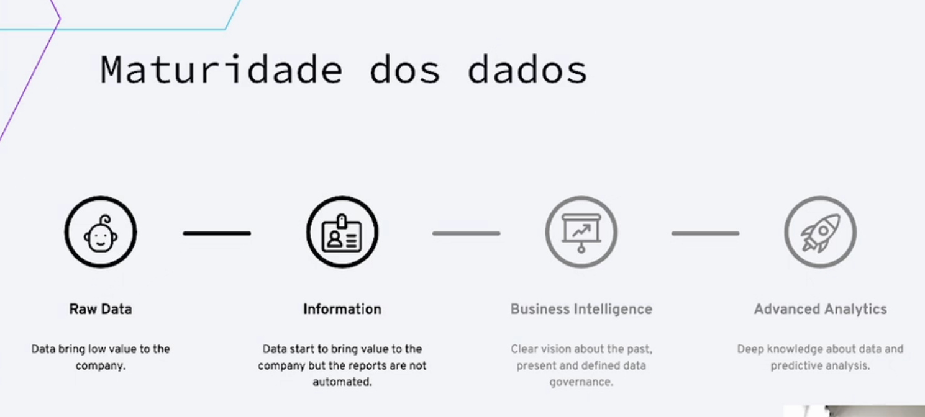

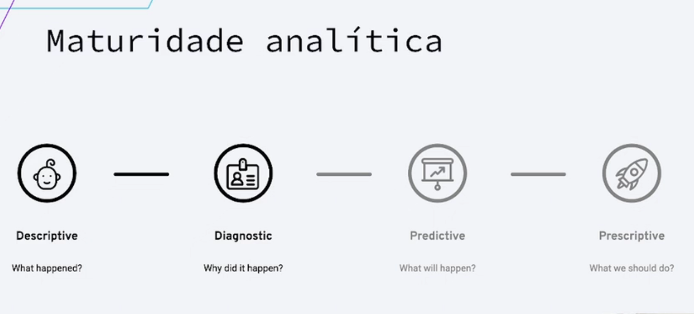

Introdução à Ciências de Dados

